

**DIGITAL LOGIC DESIGN**

**GROUP MEMBERS:**

Muhammad Awais (20P-0107)

Amaan Khalid (20P-0602)

**TOPIC NAME:**

**Liquid Leveling System**

**WORKING SOFTWARE:**

We made our circuit in soft form on Software (**Proteus 8 Professional**).

**LINK FOR DOWNLOAD PROTEUS 8 PROFESSIONAL:**

<https://www.freesoftwarefiles.com/education/proteus-professional-8-6-free-download/>

**DEFINITION:**

A Liquid level indicator is a system that relays information back to a control panel to indicate whether a container has a high or low liquid level. The purpose of a liquid level indicator is to gauge and manage liquid levels in a liquid tank.

**Apparatus:**

* BCD to Seven Segment
* 7SEG-COM-CATHODE (RED)
* OR GATE (74LS32)
* NOR GATE (74LS02)
* LOGIC TOGGLE
* LOGIC PROBE
* INPUT BUTTONS
* WIRE

**Diagram:**

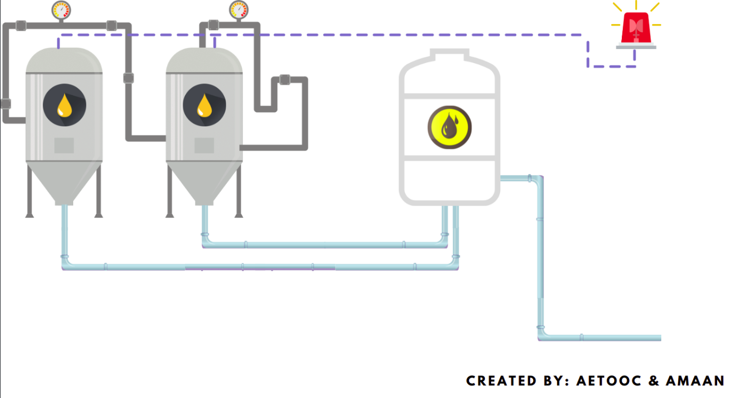

**EXPLANATION:**

Our system is liquid leveling system which contains two containers with indicates the level of liquid in the containers. We have used two BCD to 7 SEG Display separately for each container to show the level of liquids. If the level of liquid reaches 2 ft in either container the alarm buzzes off which indicates that the liquid level is decreasing and the if the level decreases below a 1 ft in either container the machine will cut down the supply of the liquid in the container which shows that the liquid level is low to continue the process. We have used a OR gate and NOR gate in this system. If any of the tank reaches 2 ft, the alarm will be activated due to the OR Gate and if any of the tank is about to get empty, the liquid supply of both tanks will be cut off from the machine due to NOR Gate.

**Circuit Diagram of Un-simplified Circuit:**

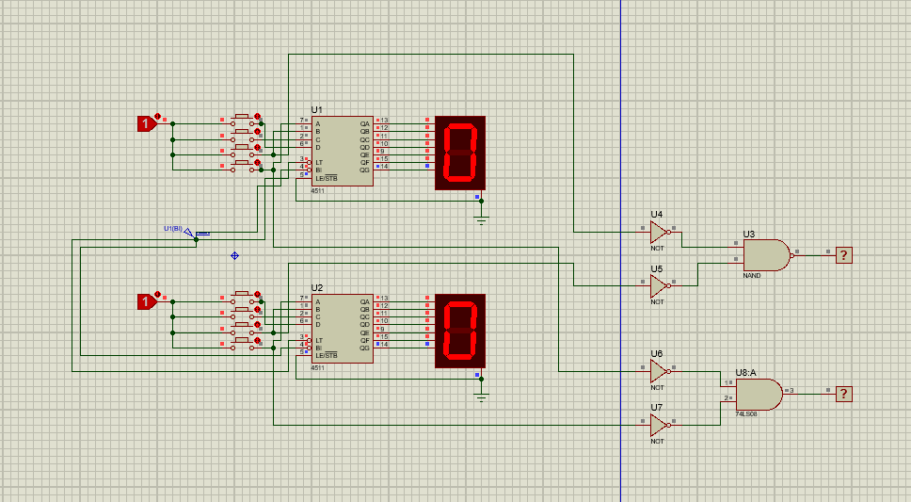

**SIMPLIFICATION**

**WARNING**

**Un-Simplified Equation:**

**WARNING**

*Warning =* ***(C1` * C2`) `***

**Truth Table:**

|  |  |  |
| --- | --- | --- |
| **C1** | **C2** | **Output** |
| 0 | 0 | 0 |
| 0 | 1 | 1 |
| 1 | 0 | 1 |
| 1 | 1 | 1 |

**KMAP**:

**C2` C2**

**C1`**

**C1**

|  |  |
| --- | --- |
| 0 | 1 |
| 1 | 1 |

**Simplified Equation**:

*Warning:* ***C1 + C2***

**CUTOFF**

**Un-Simplified Equation:**

**CUTOFF**

*Cutoff =* ***D1` + D2`***

**Truth Table:**

|  |  |  |
| --- | --- | --- |
| **D1** | **D2** | **Output** |
| 0 | 0 | 1 |
| 0 | 1 | 0 |
| 1 | 0 | 0 |
| 1 | 1 | 0 |

**KMAP**:

**D2` D2**

**D1`**

**D1**

|  |  |
| --- | --- |
| 1 | 0 |
| 0 | 0 |

**Simplified Equation**:

= **D1` * D2`**

**=** *(****D1 + D2)`*** *By De-Morgan’s Law*

*CutOff: (****D1 + D2)`***

**FINAL CIRCUIT DIAGRAM:**

